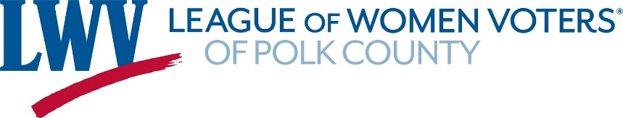
Board Meeting Via Zoom
Friday, April 21, 2023 @ 12pm
MINUTES
Voting members in attendance: Emily Crain, Bobbie Boatwright Harris, Vicki Lowe, Jessie Gomez, Sandy Sheets, Terry Lauretta, Linda Donaldson, Eileen Swiler, and Charlene Bennette
Non-Voting members in attendance: Ashley Lauretta, Karen Freedman, Katy Pace-Byrd, and Ben Graffam
Old Business: March minutes were not approved because changes had to be made on the nominating committee’s report. March minutes will be edited and then re-summitted to the board for approval via email.
Treasure Report: (Terry Lauretta) We reviewed our Statement of Financial Position as of March 31, 2023 (See attachment) that will be published in the annual meeting booklet. For clarity, Terry Lauretta emphasized that under “Current Liabilities” the $1120.00 value was reflective of dues paid after the end of the physical year in 2022 which ends in April. Also, under “Net Revenue” the value was listed as a negative $12,133.92 because the grant funds for the Lakeland Solidarity Event was given prior to April 2022, which was shown as a surplus of funds at our last annual meeting in 2022. However, the event didn’t take place until July 2022 which counts toward this physical year, 2023, hence the negative value. If you take out the grant funds we almost break even with $20 to spare.
A proposal for Treasurer for the upcoming new board was formulated: Terry Lauretta will stay on as Co-Treasurer with fellow Co-Treasurer Kristen Carlson. However, Kristen Carlson will not be able to be active as treasurer until October. In the interim Katy Pace Byrd has volunteered to help Terry Lauretta until October when Kristen Carlson can assume her duties. Kristen will be trained and guided on her duties with the understanding that Terry Lauretta will try to step back as Treasurer.
Communications Committee Report: (Ashley Lauretta) A review of the annual meeting booklet was shared and reviewed. The agenda portion of the booklet was thoroughly reviewed and edited by all board members in preparation for printing.
Annual Meeting review:
The board went over the agenda to confirm who would be speaking when and what motions (if any) were needed. We confirmed that three tables in the front lobby were needed together with the already present round table that is located in the entrance area. The first table was to be used for the signed books by Joanne ______ and Paula Mims, “Baby Shower” donation table. The second table will be for membership and registration, and the third table will be for committee sign up.
Other items needed.
- Need a projector for guest speaker. Linda Donaldson has the projector and will be bringing it with her.
- Need access to storage to get all signage for annual meeting.
- We need to create a photo power point slide of the year in review. Jessie Gomez, volunteered to create the slide show.
- Guest speaker gifts will be a book of poems and a candle. Mileage will be given to speaker at event. Terry Lauretta will be bringing the check book so that she can cut the check.

NEW BUSINESS:
- Andy Crossfield asked for board approval to form a Gun Safety Committee with Trudy Rankin as chair. He would be working with Trudy as a representative of the Mom’s Demand Action group and together they both would be working in conjunction with the Lakeland chapter of the NAACP to distribute gun locks.

A motion was made to approve the forming of a Gun Safety Committee. Motion passed. Andy fore warned that in the future the committee will come before the new board to request funds for printing of education fliers. Treasurer, Terry Lauretta, suggested that when it comes to funds to bring their proposal before the new board for discussion and approval.
- Linda Donaldson will be hosting a new board member meeting Saturday, May 20th 2023 at her house in Winter Haven. An email was sent out to all incoming board members with date, time and location of meeting.
- LWV State Convention will be held in Orlando, June 3-5, with a $250 registration fee to attend. Jessie Gomez, Linda Donaldson, and Jo Shim will be going, and possibly Trudy Rankin. LWV Polk has 6 voting delegates.
- Vicki Lowe together with a few others are looking to create a Senior League for those that can not attend events or who are not internet savvy and want to feel in the loop. For right now it is an exploratory idea.
MEETING ADJOURNED
Next board meeting will be held during our annual meeting on Wed. May 3, 2023 at the Grasslands Country Club from 10:30 – 2:00 pm.

